# Diavolo 3 Game Design Document



Derivative Games

## Overview

Diavolo 3 is an isometric hack’n’slash action RPG. The player chooses a character from one of several classes (called Archetypes) and levels them up by defeating enemies and doing quests. The character collects Equipment along the way to further boost their abilities.

There will be 4 Acts, each created as a single scene. The vertical slice will contain Act 1

It will be developed in Unity 2020.3

No major third party add-ons are required.

## Character Archetypes

Each character archetype has access to two skill trees. Skill unlock at certain levels. Every level grants the character a skill point to buy a new skill, or rank up an existing skill up to rank 10.

### Warrior

The Warrior is primarily a melee character and tank, with some team support abilities in the form of Auras that apply to the whole party (the player and their assistant character)



Base HP: 100

Base Mana: 60

### Warrior Skill Trees

**Weapon Mastery**

*The Warrior is adept with all forms of melee weapons, and can execute special attacks or gain special bonuses when using them*

* Feint – *The warrior executes a light quick attack that puts him in a superior defensive position.* Delivers (1.0 + 0.1* rank) weapon damage and add 5% to the Warrior’s Dodge for 3 seconds
* Heavy Blow – *The warrior puts all his might behind a slow powerful attack that deals superior damage.* Delivers (2.0 + 0.1* rank) weapon damage, with a (5% + rank) chance to knock the target over. Low animation. Requires Feint
* Throw Weapon – *The warrior throws his weapon at a distant target. This has the disadvantage of temporarily disarming them.* Throw your weapon up to 20m for (1.5 + 0.1*rank) weapon damage. This unequips the weapon and deposits it at the target, where you can pick it up again. Requires Heavy Blow
* Warrior’s Eye – *The warrior has a keen eye in battle, and his attacks are harder to dodge.* passive, adds 1% accuracy to all melee weapon attack per rank
* Opportunity – *The warrior can spot openings in his enemies defenses, and take advantage of them.* Passive, adds 1% chance to critical strike for double damage per rank. Requires Warrior’s Eye
* Warrior’s Focus – *The warrior can steel themselves for combat, providing a short lived damage boost.* Self click with 30 second cooldown. Adds (80+10*rank) bonus damage. Requires Warrior’s Eye

**Battlefield Command**

*The Warrior is an expert leader, and can buff allies nearby and protect themselves*

* Survival – *The warrior is an expert in armor smithing, and gains the maximum benefit from their armor.* Passive, adds 5% per rank to the Resistances granted by armor equipment.
* Battle Cry – *The warrior can rally themselves and their allies.* Self click, cooldown 30s, +10% per rank damage boost to self and all allies in 20m radius.
* Terrifying Shout – *The warrior can weaken the resolve of all enemies nearby.* Self click, cooldown 20s, -10% damage per rank debuff to all enemies within 20m. Requires Battle Cry
* Defensive Command – *The warrior reinforces nearby allies.* Aura, provides (20+2.5% per rank) damage resistance
* Offensive Command – *The warrior emboldens nearby allies.* Aura, provides +5% accuracy per rank and +5% damage per rank. Requires Defensive Command
* Invigorating Aura – *The warrior keeps his allies going in combat.* Aura, heals allies for 2hp every 2 seconds, and gain +1 mana per 2 seconds. Requires Defensive Command

(Only one Aura can be active at a time)

### Mage

The Mage is primarily a ranged character glass cannon, who can defend themselves with control abilities and high damage.

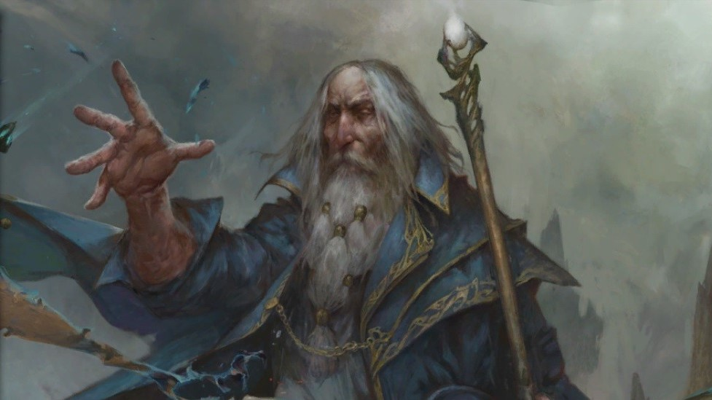

Base HP: 80

Base Mana: 120

### Mage Skill Trees

**Elementalism**

*The Mage can control the elements and shape them into deadly ranged attacks*

* Firebolt – *The mage throws a ball of fire at their opponent, doing damage and damage over time.* Delivers 3-10 fire damage and 50% chance of 2 damage/s for 5 seconds. +10% damage per rank
* Fireball – *The mage throws a burning projectile that explodes on impact, setting their enemies on fire.* Deals 3-10 fire damage and 2 damage/s for 5 seconds in an 8m radius. +10% damage per rank. Requires Firebolt
* Ice Shard – *The mage throws a sharp ice projectile, dealing damage and slowing the target.* Deal 2-8 Piercing damage and -20% speed for 10 seconds
* Ice Ray – *fires a continuous beam inflicting cold damage and slowing opponents. 4 cold damage*, -50% speed for 10 seconds, channeled, ticks every 0.5 seconds. Requires Ice Shard
* Lightning Field – *the mage surrounds himself with a field of static electricity, damaging and repelling opponents.* 2 damage/second, 10% chance of knockback in 5m radius.
* Chain Lightning – *the mage fires a lightning bolt that jumps from target to target.* 3-10 electrical damage, arcs to next target within 10m range.

**Incantations**

*The Mage can direct pure magical energy to affect their will in combat*

* Healing Charm – *The mage can restore health to themselves or an ally.* 10-20 healing, 6 second cooldown
* Mystic Power – *The mage can increase their offensive capabilities*. +100% damage for 10 seconds, 30 second cooldown
* Magic Shield *– The mage can create a mystical force field to protect themselves from damage*. +50% damage resistance for 10 seconds, 20 second cooldown. Requires Healing Charm
* Time Crawl – *The mage can hold a target character stationary in time* +100% Hold for 8 seconds, 12 second cooldown
* Time Stop – the Mage can hold all nearby enemies stationary + 100% Hold for 8 seconds in 5m PBAoE radius, 24 second cooldown. Requires Time Crawl
* Enchantment – *The mage enforces his will on a weaker minded creature* +100% Confuse for 20 seconds, 20 second cooldown. Requires Time Crawl

## Equipment

Each Character can equip one item in the following slots:

* Helmet
* Armor
* Gloves
* Boots
* Belt
* Amulet
* Ring1
* Ring2
* Left Weapon/Shield
* Right Weapon

Each item may gives a base Buff for their quality and type of item to Attack rating or Defence Rating.

|  |  |  |  |
| --- | --- | --- | --- |
|  | Low | Medium | High |
| Armor | +8 DR | +16 DR | +32 DR |
| Shield | +10 DR | +20 DR | +40 DR |
| Helmet/Glove/Boots | +5 DR | +10 DR | +20 DR |
| Weapon | +5 AR | +10 DR | +20 AR |

Other buffs can then be added to the equipment randomly. Magic items gets one suffix or prefix. Rare items get both a prefix and suffix from the following table. Ultra items get two prefixes.

Prefixes

|  |  |
| --- | --- |
| Ruby | +10% Fire resistance |
| Emerald | +10% Poison resistance |
| Amethyst | +10% Lightning resistance |
| Sapphire | +10% Cold resistance |
| Diamond | +5% all resistance |
| Speedy | +20% Speed, +20% Cooldown speed |
| Vampiric | +2 life steal per attack |
| Sturdy | +10% max health |

Suffixes

|  |  |
| --- | --- |
| of Hera | +20% all Damage |
| of Ares | +2 mana per attack |
| of Aphrodite | 1hp/s heal over time |
| of Zeus | 20% of 3-8 lightning damage per attack |
| of Hermes | +20% Speed, +20% Cooldown speed |
| of Artemis | +20% accuracy |

e.g a Rare Item might drop as

***Ruby Skull Cap of Artemis***

*+10 Defence Rating*

*+10% Fire Resistance*

*+20% Accuracy*

### Potions

Potions are consumables that the character can carry.

Health Potion: +40% Health

Greater Health Potion: +80% Health

Mana Potion: +40% Mana

Greater Mana Potion + 80% Mana

Purple Potion: +50% Health, +50% Mana

## Enemy NPCs

Enemy NPCs come in three ranks:

Minion: 20hp, -20% damage

Normal: 40hp

Boss: 100hp, +50% damage

Each rank has a standard RewardTable set up for their item and gold drops, although this can be overridden by a custom reward table for any enemy placed in the level via a Spawner.

## Quests and Dialog

## Act 1

### Quest 1

**Katnyss (Leader of the town guard mercenaries)**

First Intro: “A hero eh? I keep the peace here with my amazons. You could be of help”

Introduction: “The people of this town are scared. The witch Blood Raven has descended from the North. We need your help defeating her.”

In progress: “I shall not be satisfied until Blood Raven is gone”

Completion: “Remarkable! You are now an honorary captain of my guard. You may select a warrior to accompany you on further adventures.”

### Quest 2

**Roderick Cain (Travelling wise man/hermit)**

First Intro: “I have seen many things on my travels”

Introduction: “The mystical artifact called the Icosahdren has been stolen. You must travel to the village of Wirtshire to retrieve it”

In progress: “The Icosahedren is vital for our war against Diavolo!”

Completion: “Ahh, such a remarkable item. Crafted when the world was young. You must keep it.”

### Quest 3

**Charise (Blacksmith)**

Introduction: “You know I said my Uncle was a warrior? Well, a giant metal bull stole his hammer. Can you get it back for me?”

In progress: “I could make some awesome armor if I had my uncle’s hammer!”

Completion: “Supercool! What can I make for you then? It’s on the house!”

## Merchants

**Charise (Blacksmith, sells armor and weapons, and repairs equipment)**

First Intro: “Hi, you look like you could use some new equipment!”

(Warrior Only): “Wow, you’re a warrior! My uncle was a Warrior, he braided his beard the same way as yours.”

Subsequent intros: “Hey hero. What can I do you for?”

**Alchezar (Apothecary, sells potions and magic wands)**

First intro: “A hero, eh? You’ll need all the strength you can get out there.”

(Mage Only): “As a fellow practitioner of the subtle arts, I bid you welcome, Mage!”

Subsequent intros: “Come, browse my selection of subtle brews.”

## NPC Enemies

## Goblins

Minions: Basic melee attack with sword or axe (randomly chosen at instantiation), high mobility

Shaman: Heals and resurrects minions, tries to stay 10m from the player to avoid melee

Bosses: Scaled up minion with shield, and random magical attribute

## Blood Followers

Minion: human followers of Blood Raven. Random poleaxe/spear weapon, run straight at player

## Blood Raven

Quest Boss character

* Melee attack with spear
* Lightning area attack with stun, 20 second cooldown

## Talos (metal bull man)

Quest Boss character

* Melee attack with hammer, slow animation telegraphs
* Charge attack, closing distance quickly
* Moves at walking speed
* Resistance to all damage except lightning